Ideation Phase Brainstorm & Idea Prioritization

|  |  |
| --- | --- |
| Date | 01 OCTOBER 2022 |
| Team ID | PNT2022TMID20770 |
| Project Name | Digital Naturalist - AI Enabled Tool For  Biodiversity Researchers |
| Maximum Marks | 4 Marks |

Brainstorm & Idea Prioritization:

Step-1: Team Gathering, Collaboration and Select the Problem Statement

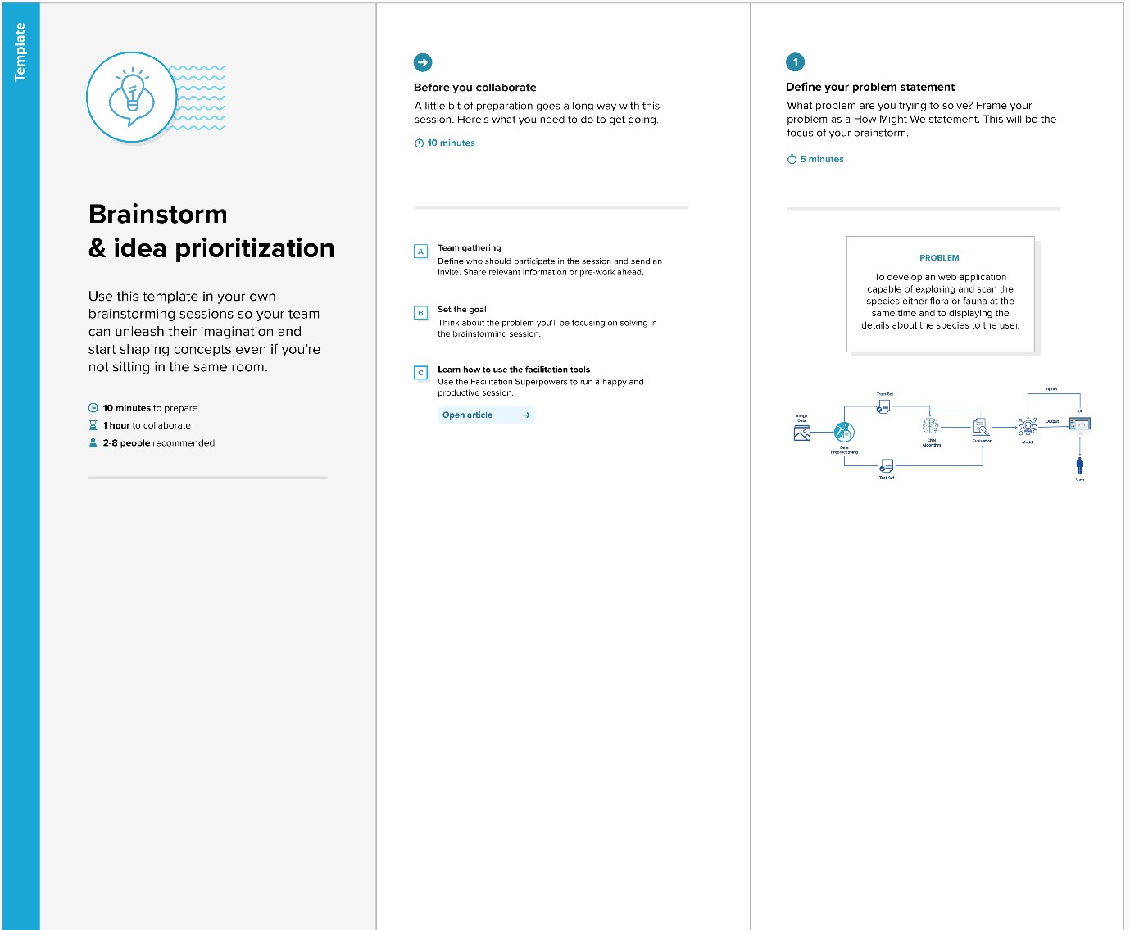

Step-2: Brainstorm, Idea Listing and Grouping

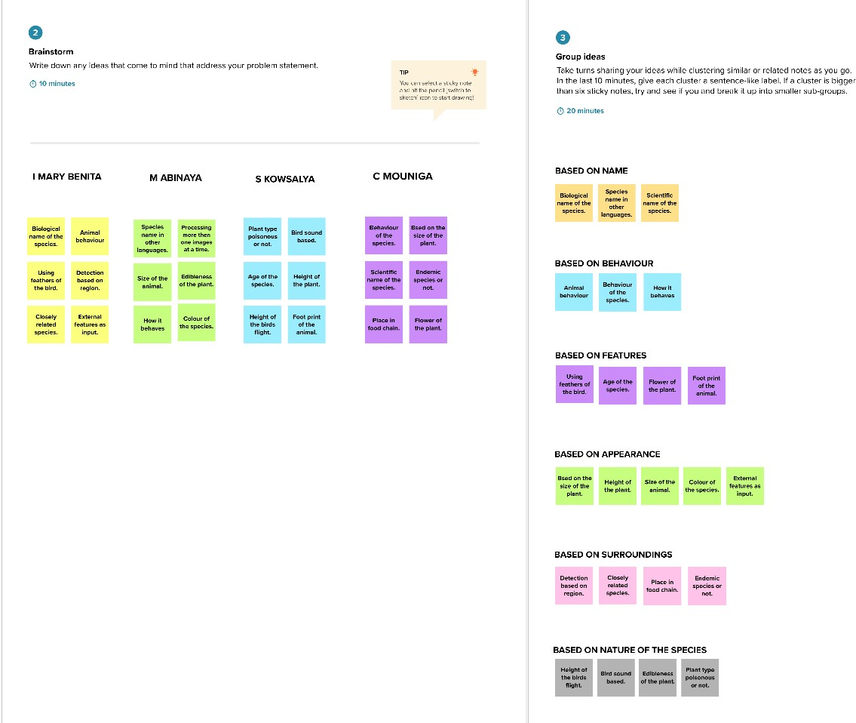

Step-3: Idea Prioritization

